2013-2017 International Exchange
2017
- 2017.09.25-09.28Dr. Ming-Chung Chou, chairman of Department of Medical
Imaging and Radiological Sciences, was invited to visit and give a presentation in Ibaraki Prefectural University of Health Sciences.
- 2017.09.01 Students from Department of Health Technology & Informatics, The Hong Kong Polytechnic University came for a summer training in Department of Laboratory Medicine in Chung-ho Memorial Hospital, Kaohsiung Medical University upon the Memorandum of Undertaking singed by two school.
- 2017.08.22Dr. E-Fong Kao, the teacher of Department of Medical Imaging and Radiological Sciences, participated in the exchange forum with teachers and students from Okayama University.
- 2017.08.16-08.23 Dr. Ming-Chung Chou, the chairman of Department of Medical Imaging and Radiological Sciences, led two students, Chih-Yun Wu and Chuan-Yu Wang, to take one-month overseas clinical placement in Ottawa Hospital Cancer Centre.
- 2017.08.14-08.26 Two PT3 students (Mr Tsui/Li) visited the TAGS Physiotherapy Center, Malaysia, for 2-week overseas internship.
- 2017.08.13-08.16 Professor Hui-Yi Wang accompanied the above mentioned students to the TAGS Physiotherapy Center, Malaysia, for 1 week.
- 2017.08.06-08.19 Three PT3 students (Ms Huang/Jiang/Yang) visited the Loving Physiotherapy Center, Macao, for 2-week overseas internship.
- 2017.07.17-07.20 Professor Hui-Yi Wang accompanied the above mentioned students to the Loving Physiotherapy Center, Macao, for 1 week.
- 2017.07.17-07.29 Three PT3 students (Ms Wu/Wu/Lin) visited the Loving Physiotherapy Center, Macao, for 2-week overseas internship.
- 2017.07.10-08.11 Four PT3 students (Mr Li/Wu and Ms Jhou/Yu) visited the Borneo Specialist Hospital, Malaysia, for 5-week overseas internship.
- 2017.07.09-07.12 Professor Hui-Yi Wang accompanied the above mentioned students to the Borneo Specialist Hospital, Malaysia, for 1 week.
- 2017.07.04 Dr. Ming-Chung Chou, chairman of Department of Medical Imaging and Radiological Sciences, visited Department of Radiological Technology in Hokkaido University of Science, and built an initial collaborative relationship between the two departments.
- 2017.07.02-07.30 Four PT3 students (Ms Chen/Wang/Lai and Mr Tsui) visited the Faculty of Health Sciences, Hokkaido University, Japan, for 4-week overseas internship.
2017.07.02-07.08 Dr Shih-fen Hsiao accompanied the above mentioned students to the Faculty of Health Sciences, Hokkaido University, Japan, for 1 week.
- 2017.07.02-07.30 Dr. Ming-Chung Chou, chairman of Department of Medical Imaging and Radiological Sciences, led two undergraduate students, Chiao-Lang Liang and Chun-Ju Kao, to take overseas observership in Division of Radiological Science and Technology, Department of Health Science, Hokkaido University, Japan.
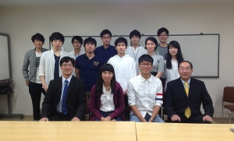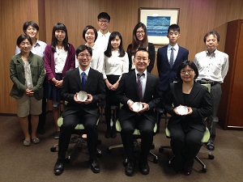
- 2017.06.25-07.22 Two PT2 students will visit Ibaraki Prefecture University (IPU) for a four-week community PT internship program.
- 2017.06.25-06.28 Department Head Dr Miao-Ju Hsu will accompany PT students to IPU for the internship program.

2016
- 2016.09.26-09.28 International exchange activity and coteaching
1.International exchange with IPU
2.Coteaching: Dr. Okuno presented “Cardiopulmonary Physical Therapy in Japan”
- 2016.05.11-05.13 International undergraduates of Dep. of MLSB hold a 3-day International Week event.
(Host: Department of Medical Laboratory Science and Biotechnology)
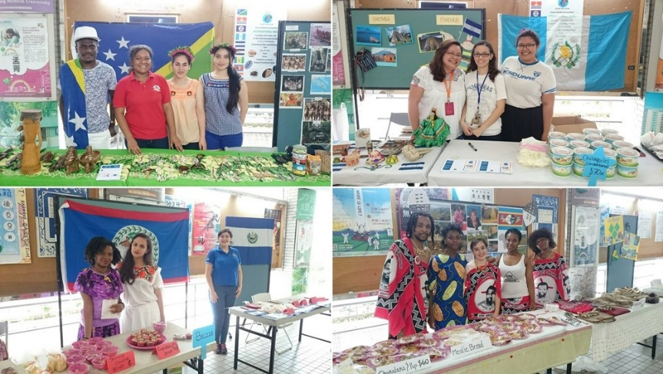
- 2016.02.22 Department of Public Health invited Harvard scholar Chensheng Alex Lu to give a speech of [the disappearing bees in a global: the future of environmental health risk assessment]. This speech received an enthusiastic response from the audience.
(Host: Department of Public Health)
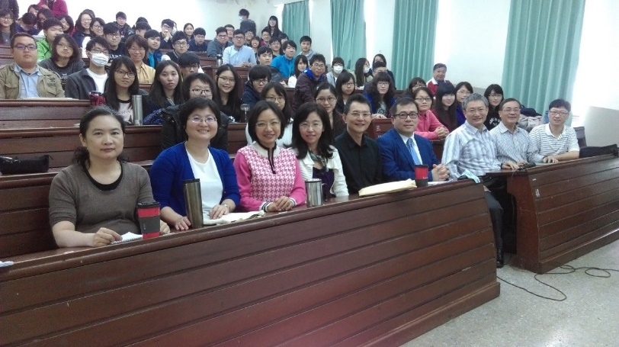
- 2016.01.06 - 15 Nine graduate students of Harvard School of Public Health obtained the funding from the [KMU-Harvard Foundation]and came to Taiwan to take the joint course of [Field Experience in International Occupational Safety and Health] with graduate students of Department of Public Health together at KMU. (Host: Department of Public Health)
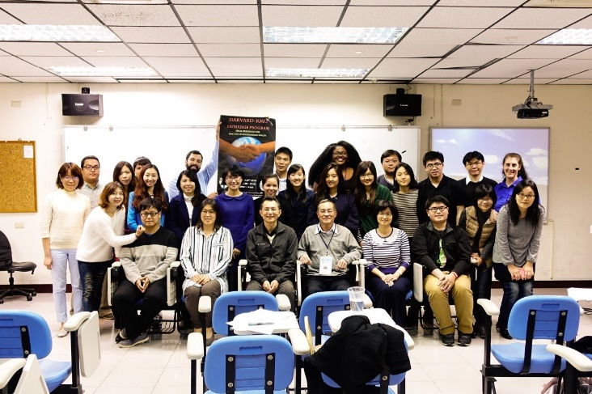

2015
- 2015.12.16 International undergraduates of Dep. of MLSB performed Taiwanese songs with local students.
(Host: Department of Medical Laboratory Science and Biotechnology)
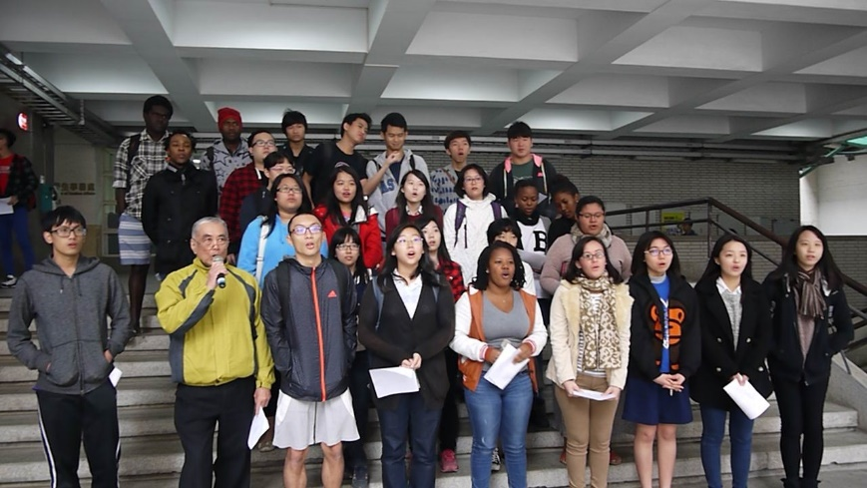
- 2015.10.06 Professor Tsu-Nai Wang, professor Pei-Shih Chen, and associate Professor Hui-Min Hsieh discussed about research interests with professor Sandra Winter of Stanford University Preventive Research Center at KMU. (Host: Department of Public Health)
- 2015.08.18 Dr. Marc Potvin (The Michener Institute, Toronto, Canada) visit Department of Medical Imaging and Radiological Sciences
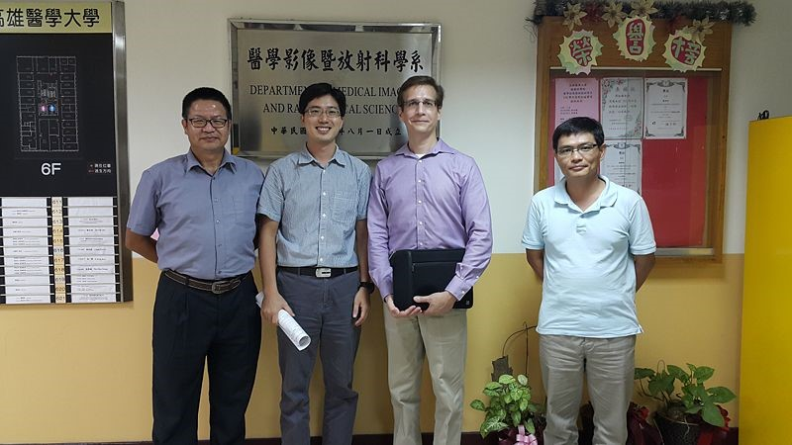
- 2015.07.27-08.01 Prof. Hui-Yi Wang and five undergraduate students attended overseas clinical practice in Bintulu Medical Center and Rejang Healthcare Center at Malaysia
(Host: Department of Physical Therapy)
- 2015.07.04-07.09Associate professor Yiter Chen led the students to intern Mahkota Medical Centre, Malaysia. (Host: Department of Healthcare Administration and Medical Informatics)
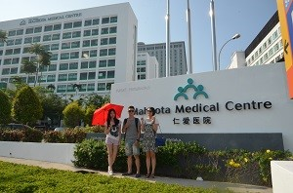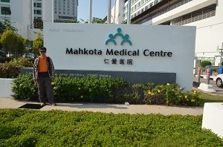
- 2015.06.22 Mrs Chou, senior lecturer, and 10 senior undergraduate students participated the overseas internship program in Ibaraki Prefectural University, Japan.
(Host: Department of Occupational Therapy)
- 2015.05.18 14 senior undergraduate students from Department of Rehabilitation Sciences, Hong Kong Polytechnic University, visited the Department of Occupational Therapy.
(Host: Department of Occupational Therapy)
- 2015.05.08 Prof. Hui-Yi Wang and assistant Prof. Yun-Huei Ju attended 「The physical therapist assessment of Spinal Muscular Atrophy in clinical study」at Osaka (Host: Department of Physical Therapy)
- 2015.04.13，Dr. Tyrone Goh (Executive Director) and Ms. Lim Soh Har (General Manager) of National Healthcare Group in Singapore visited Department of Medical Imaging and Radiological Sciences and joined the discussion with Dr. Chun-Wei Li, Dr. E-Fong Kao and 4th grade undergraduates.
- 2015.03.27 Sister school Kyushu University, Japan visited Department of Medical Imaging and Radiological Sciences and Department of Medical Laboratory Science and Biotechnology.
- 2015.03.15-18 Dr. Li-Fang Wang (Dean of Life Sciences), Dr. Hui-Yi Wang (Dept . Chair of Physical Therapy), Dr. Shih-Fen Hsiao (Dept. of Physical Therapy), Dr. Ming-Chung Chou (Dept. of Medical Imaging and Radiological Sciences) visited the Faculty of Health Science, Hokkaido University, Japan.
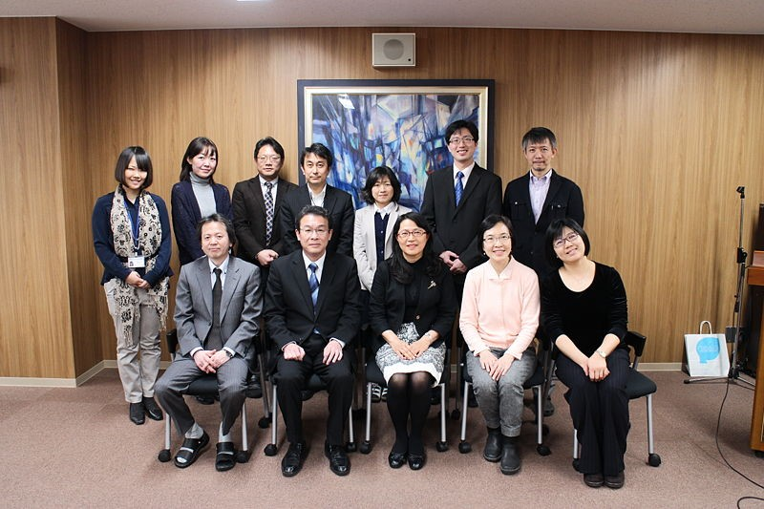
- 2015.3.6-3.19Senior students of In Services Master degree participated in
Virginia Commonwealth University to attend the course entitled “Special Topics in US Hospital Management” (Host: Department of Healthcare Administration and Medical Informatics)
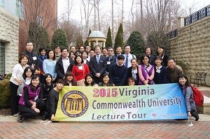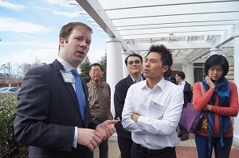
- 2015.02.25-28，Dr. Chia-Ju Chen and a 3rd grade undergraduate Mr. Jung-Yi Yang visited Tokyo University.
(Host: Department of Medical Laboratory Science and Biotechnology)

2014
- 2014.12.11 Invited speaker: Prof. Pauline Rudd (National Institute for Bioprocessing Research and Training and Conway Institute of Biomolecular And Biomedical Research in University College Dublin) in “Integrating Glycomics into Systems Biology”
(Host: Department of Medical Laboratory Science and Biotechnology,
Co- Host: Department of Medical Imaging and Radiological Sciences)
- 2014.12.08 Prof. Mari Carmen Lillo Navarro from Miguel Hernanedz University held special speech「Introduction to Reeducation Postural Global」at Kaohsiung Medical University
(Host: Department of Physical Therapy)
- 2014.08.06~08 Mrs Chou, senior lecturer, visited the OSCE system at the epartment of Occupational Therapy, Ibaraki Prefectural University
(Host: Department of Occupational Therapy)
- 2014.07.28-08.08 Prof. Hui-Yi Wang and four undergraduate students from Kaohsiung Medical University attended oversea clinical practice in Sussex Physiotherapy Clinic at Australia
(Host: Department of Physical Therapy)
- 2014.07.24 Four senior undergraduate students participated the overseas internship program for 6 weeks in Monash University, Australia.
(Host: Department of Occupational Therapy)
- 2014.07.12-26 Assistant Prof. Shu-Mei Chen and four undergraduate students attended overseas clinical practice in Physiotherapy department of Chera at Malaysia
(Host: Department of Physical Therapy)
- 2014.07.01-03Professor Herng-Chia Chiu participated in Continental Hospital Management Institute of Tsinghua University to give a lecture.
(Host: Department of Healthcare Administration and Medical Informatics)
- 2014.03.24. Department of Public Health, KMU invited Prof. David Christiani of the Harvard School of Public Health giving a keynote speech entitled as “Environmental Causes of Cancer” at the Kaohsiung Medical University.
(Host: Department of Public Health)
- 2014.03.18 Prof. Setsuo Sugishima, Prof. Yuzo Kayamori, and Prof. Reiko Minakami from Kyushu University, Japan visited Department of Medical Laboratory Science and Biotechnology
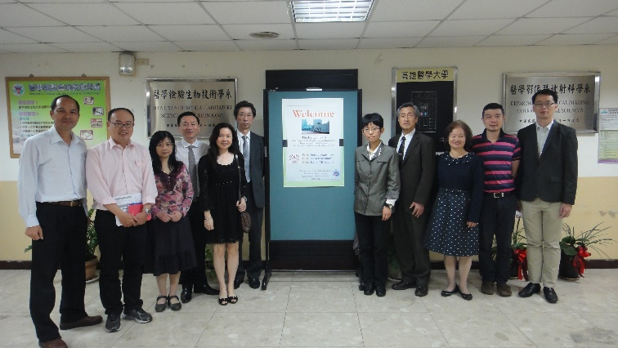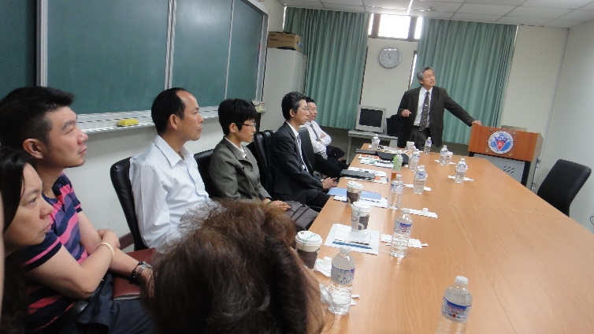
- 2014.03.18 Dr. Hidetaka Arimura, Dr. Seiji Kumazawa, Dr. Toshioh Fujibuchi, and Dr. Yukata Yoshida from the Division of Medical Quantum Science, Faculty of Health Science, Kyushu University, Japan visited the Department of Medical Imaging and Radiological Sciences.
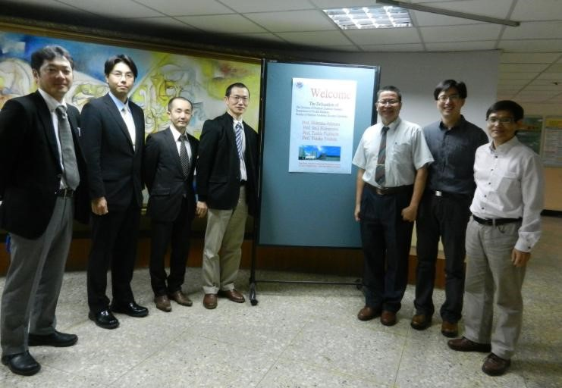
- 2014.01.08- 17 Twenty graduate students of Department of Public Health and 10 graduate students of Harvard School of Public Health took the joint course of [Field Experience in International Occupational Safety and Health] together at KMU.
(Host: Department of Public Health)

2013
- 2013.12.28Prof. Thomas T. H. Wan（College of Health and Public Affairs, University of Central Florida） was invited to give a lecture entitled “Evolving U.S. Health Care System” in Alumni 2013.
(Host: Department of Healthcare Administration and Medical Informatics)
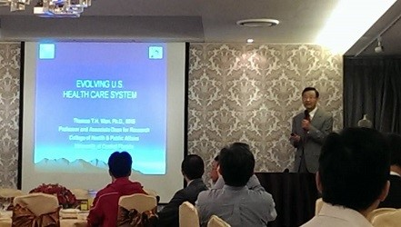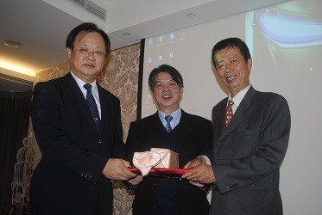
- 2013.12.28Prof.Thomas T. H. Wan（College of Health and Public Affairs, University of Central Florida） was invited to give a lecture entitled “Evolving U.S. Health Care System” in Alumni 2013.
(Host: Department of Healthcare Administration and Medical Informatics)
- 2013.11.20-22 Prof. Wu and Prof. Lee visited Kyushu University, Japan for the 8th International Forum of Health Sciences in Kyushu University 2013(Department of Medical Laboratory Science and Biotechnology and Department of Medical Imaging and Radiological Sciences)
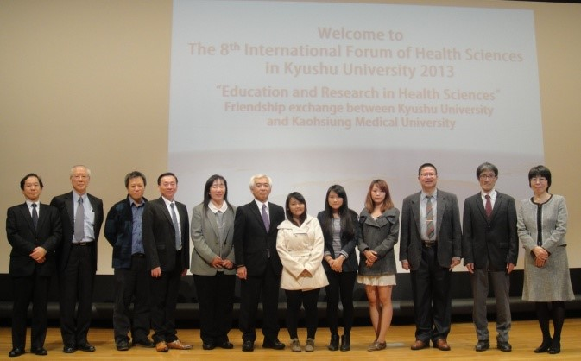
- 2013.08.08-25 Eight undergraduate students attended overseas clinical practice in Physiotherapy Department of Cheras HSC at Malaysia
(Host: Department of Physical Therapy)
- 2013.07.21-08.04 Eight undergraduate students attended overseas clinical practice in Physiotherapy department of Cheras HSC at Malaysia
(Host: Department of Physical Therapy)
- 2013.05.27 Tulane University School of Public Health's delegation visited the Department of Public Health, KMU. Both groups discussed the graduate student exchange program and teaching-related issues.
(Host: Department of Public Health)
- 2013.05.22 Associate Professor Hui-Min Hsieh gave a talk of [health care system of Taiwan] to students of Canadian McGill University when they visited KMU.
(Host: Department of Public Health)
- 2013.04.15Assistant professor Hao-Yun Kao was invited to teach a course entitled “Health insurance system in Taiwan” for Clerkship Program for Harvard Medical Students.
(Host: Department of Healthcare Administration and Medical Informatics)
- 2013.03.19 Graduate students from Division of Medical Quantum Science, Faculty of Health Science, Kyushu University visited the Department of Medical Imaging and Radiological Sciences.
- 2013.03.01-14Senior students of In Services Master degree participated in
Virginia Commonwealth University to attend the course entitled “Special Topics in US Hospital Management” (Host: Department of Healthcare Administration and Medical Informatics)
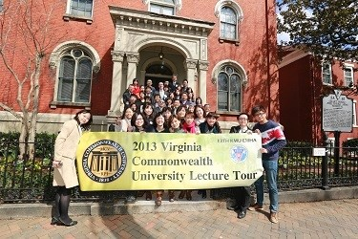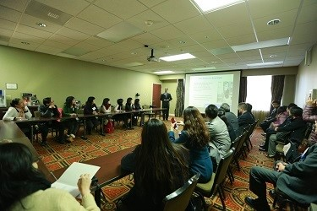
- 2013.01.31 Prof. Chang from The Chinese University of Hong Kong visitedDepartment of Medical Laboratory Science and Biotechnology
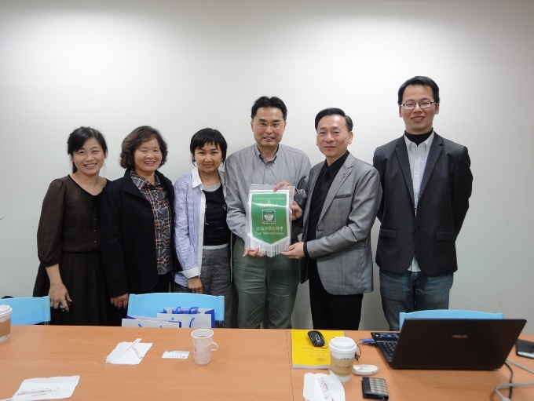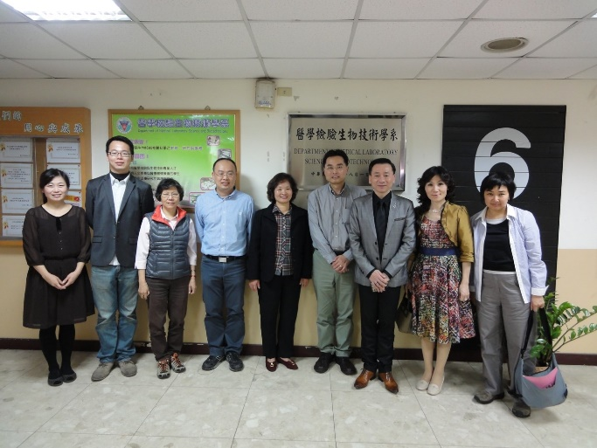
- 2013.01.15 The Department of Medical Imaging and Radiological Sciences and Department of Medical Laboratory Science and Biotechnology invited Prof. Ching-Shih Chen (College of Pharmacy, The Ohio State University ) to give a talk with the topic of “Targeting Tumor Microenvironment-Driven Cancer Progression by Novel Therapeutic Agents”.

